NEW ADMISSION 2024-25
STEP BY STEP PROCEDURE FOR ONLINE PAYMENT

After clicking on deposit https://www.onlinesbi.sbi/sbicollect/icollecthome.htm you get the SBI Collect Portal as shown in Step 1.
STEP 1

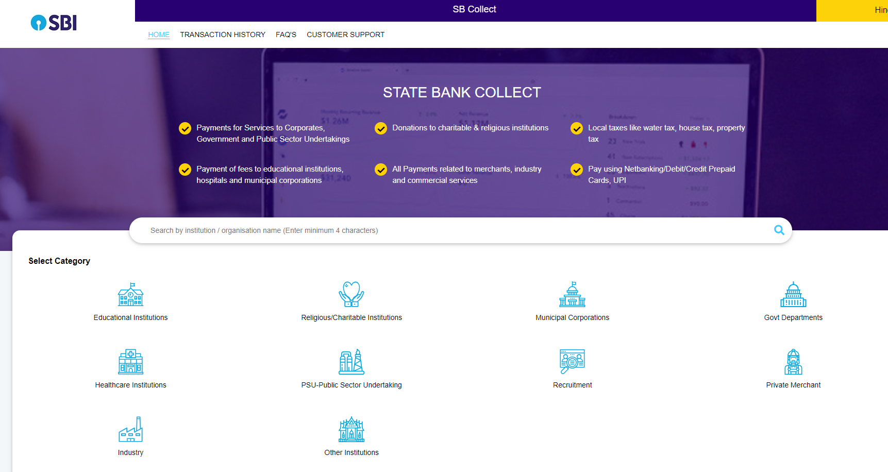

- Select the Education Institution under SB Collect

STEP 2

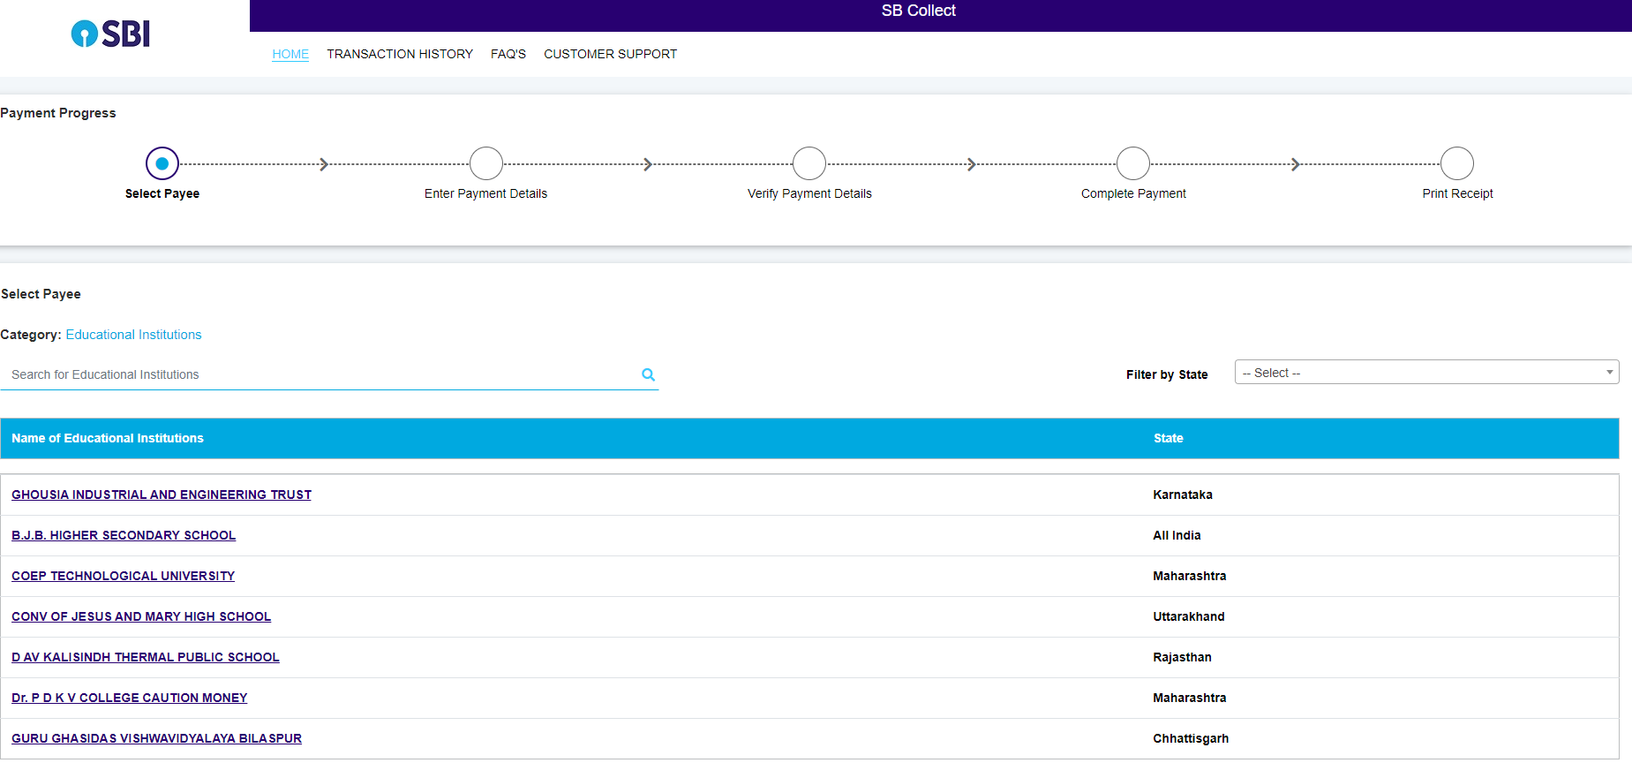
- After Selecting Educational Institution,Screen shown in step 2 will be open
- Here you have to type Rajiv Gandhi National University of Law and then select

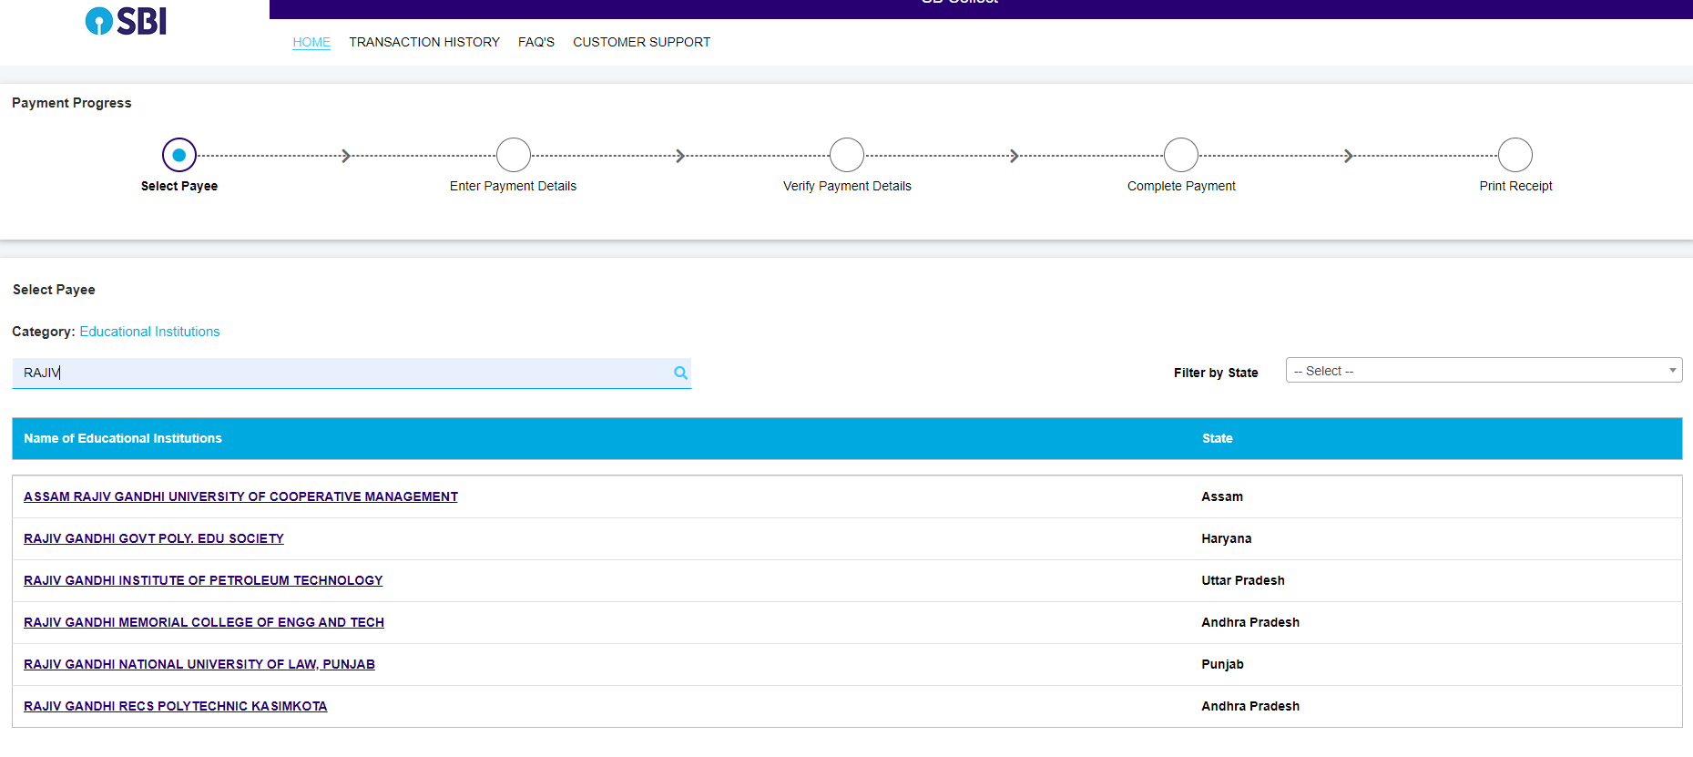
STEP 3

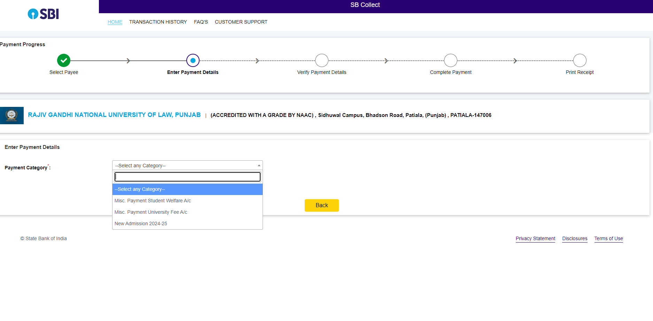

- After selecting Rajiv Gandhi National University of Law in Step 2, next window as shown in Step 3 will be open.

- Select the tab i.e. New Admission 2024-25

STEP 4

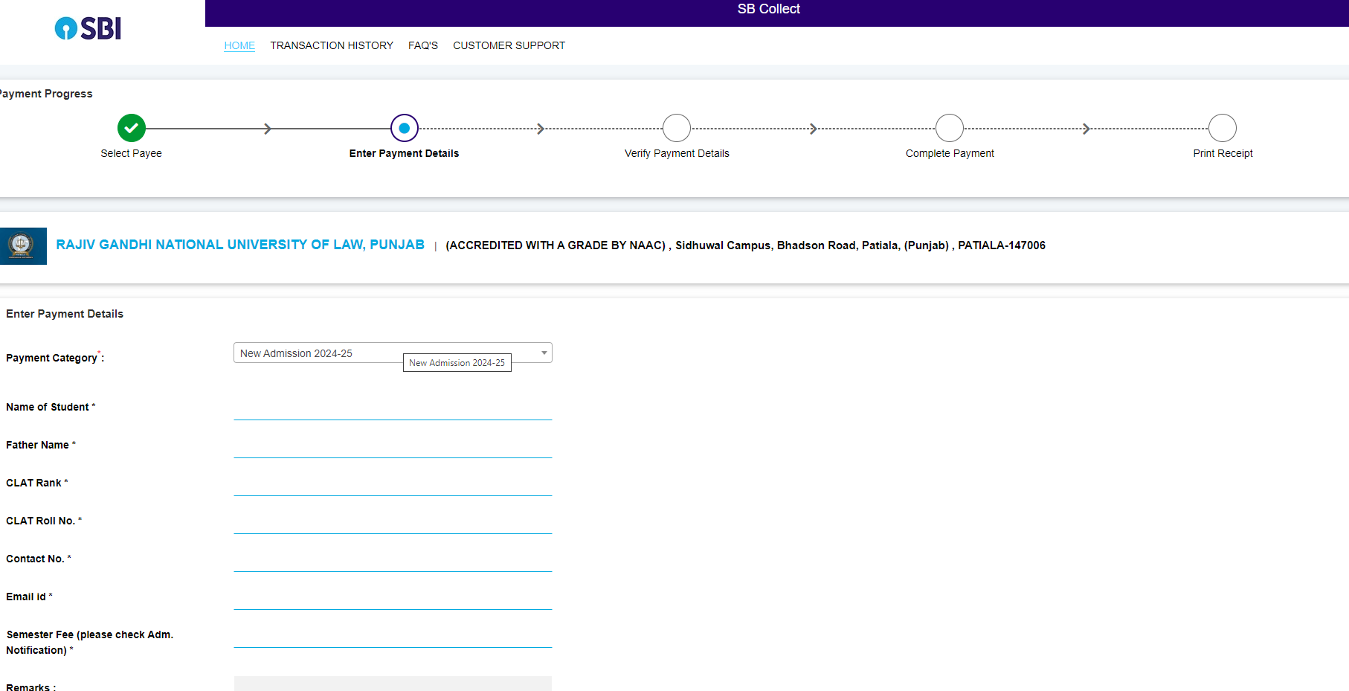
- Fill the detail in the form( format shown In Step 4) under RGNUL Name and logo and click next.

STEP 5

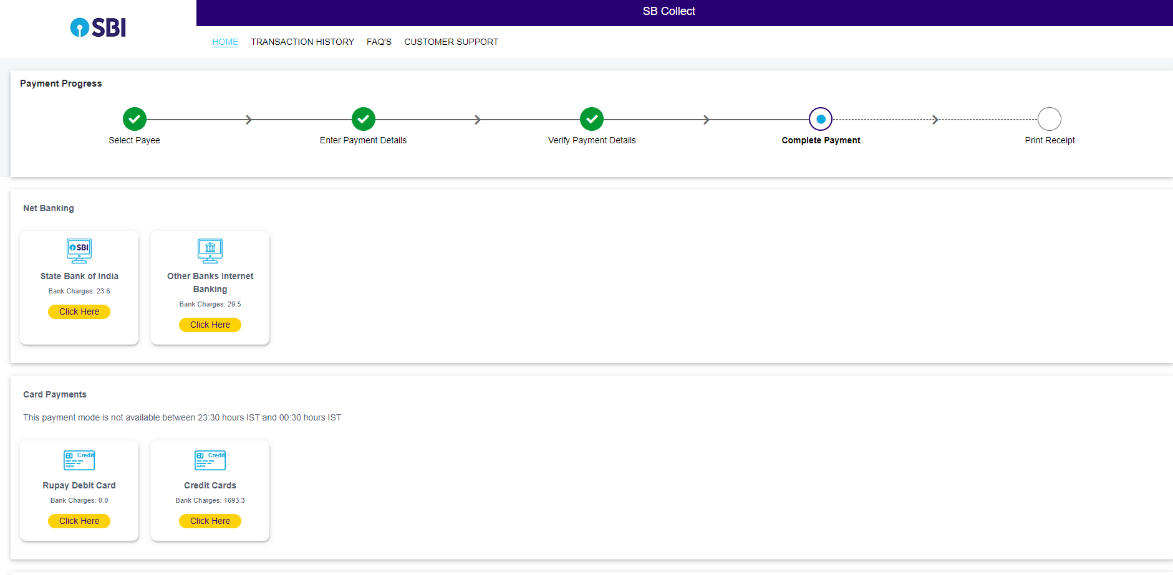

- SELECT THE MODE OF PAYMENT AS MENTIONED IN STEP 5 AND DEPOSIT THE FEES
- AFTER DEPOSIT THE FEE, SEND THE FEE DEPOSIT RECEIPT.

FOR ANY KIND OF ASSISTANCE ON ANYSTEP STUDENT CAN CONTACT ON TELEPHONE NO.0175-2391251,256 during 10.00AM to 4.00PM only on working days.

>> HOPE YOU MAY FIND OUR EFFORT INNOVATIVE & HELPFUL <<

