STEP BY STEP PROCEDURE FOR ONLINE PAYMENT OF
SEMESTER FEE AND MESS FEE

After clicking on deposit “online fee payment or https://www.rgnulerp.org/student/login/login.jsp you got the Libsys Student Portal.
IMPORTANT INFORMATION --- STUDENTS CAN DEPOSIT ONLINE SEMESTER FEE and MESS FEE FROM ANY ACCOUNT OF ANY BANK . WHETHER ITS HIS/HER MOTHER/FATHER 'S ACCOUNT FROM ANY BANK.

> Fill Login ID and password (Login ID is Roll number and first password is date birth and first 2 digit of your name)

> Click on symbol
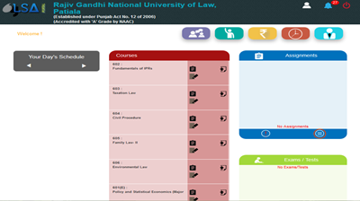

Check semester fee and mess fee with fee structure provided to you during the last semester examination. If any discrepancy in it please contact to Accounts branch 0175-2391254.
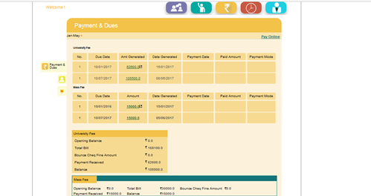

If all fee details Ok click on Pay online and select category

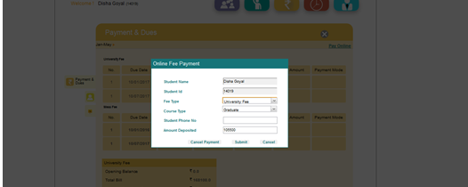
> Select the mode of payment
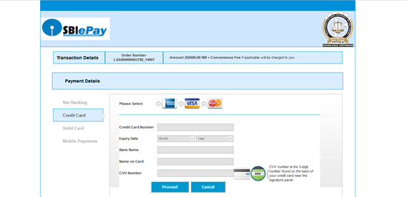
> STUDENTS SHOULD CORRECTLY SEE THE BANK CHARGES ON DIFFERENT MODES OF PAYMENT, they are on a higher side (varying with the amount) for OTHER BANKS DEBIT CARD & CREDIT CARD OPTION, so in this regard they are advised to use net banking.

FOR ANY KIND OF ASSISTANCE ON ANYSTEP STUDENT CAN CONTACT ON TELEPHONE NO.0175-2391254 during 10.00AM to 4.00PM only on working days.

>> HOPE YOU MAY FIND OUR EFFORT INNOVATIVE & HELPFUL <<

